**Programming a page to control the arm using the web series API, writing the Arduino code with the control**

**Arm-control-using-Web-Serial-API-and-Arduino-code What is the Web Serial API?**

**The Web Serial API provides a way for websites to read from and write to a serial device with JavaScript. Serial devices are connected either through a serial port on the user's system or through removable USB and Bluetooth devices that emulate a serial port.**

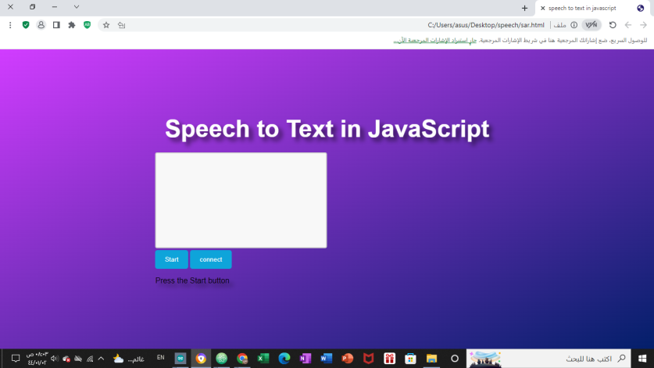**Required In The Assignment :**

1. **Create a web page that**

**converts audio to text**

1. **We connected it with arduino**

**connected with servo motor**

**3- When we say right, the motor moves to 180**

**degrees, and when we say left, the motor moves to zero degrees**

**command**

**if you have servo you can test the script connect the servo to pin 8 and write this command in seral monitor**

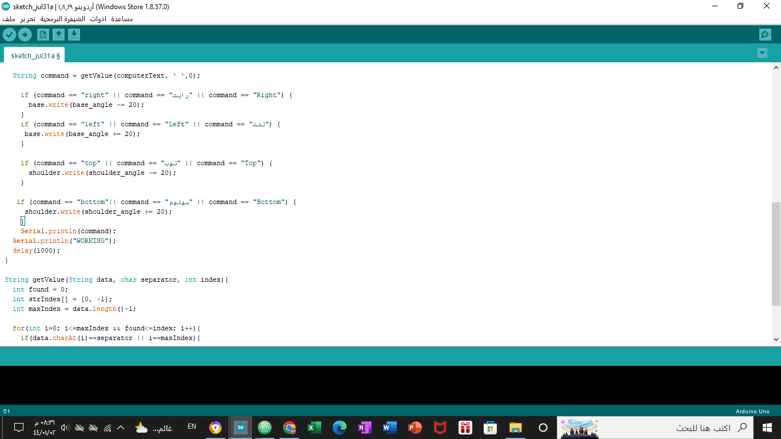**left@ right@ top@**